Figure 1: Bar Chart – Sales by Category and Region
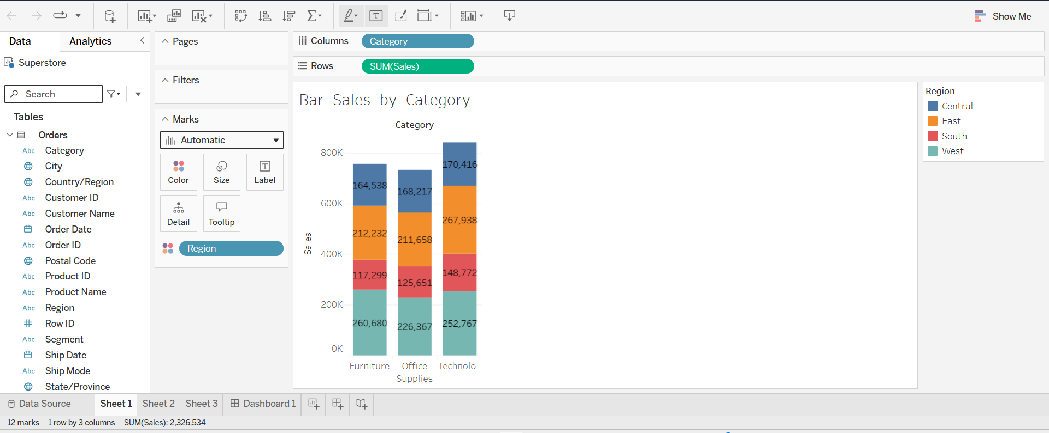

Figure 2: Line Chart – Monthly Sales Trend by Region
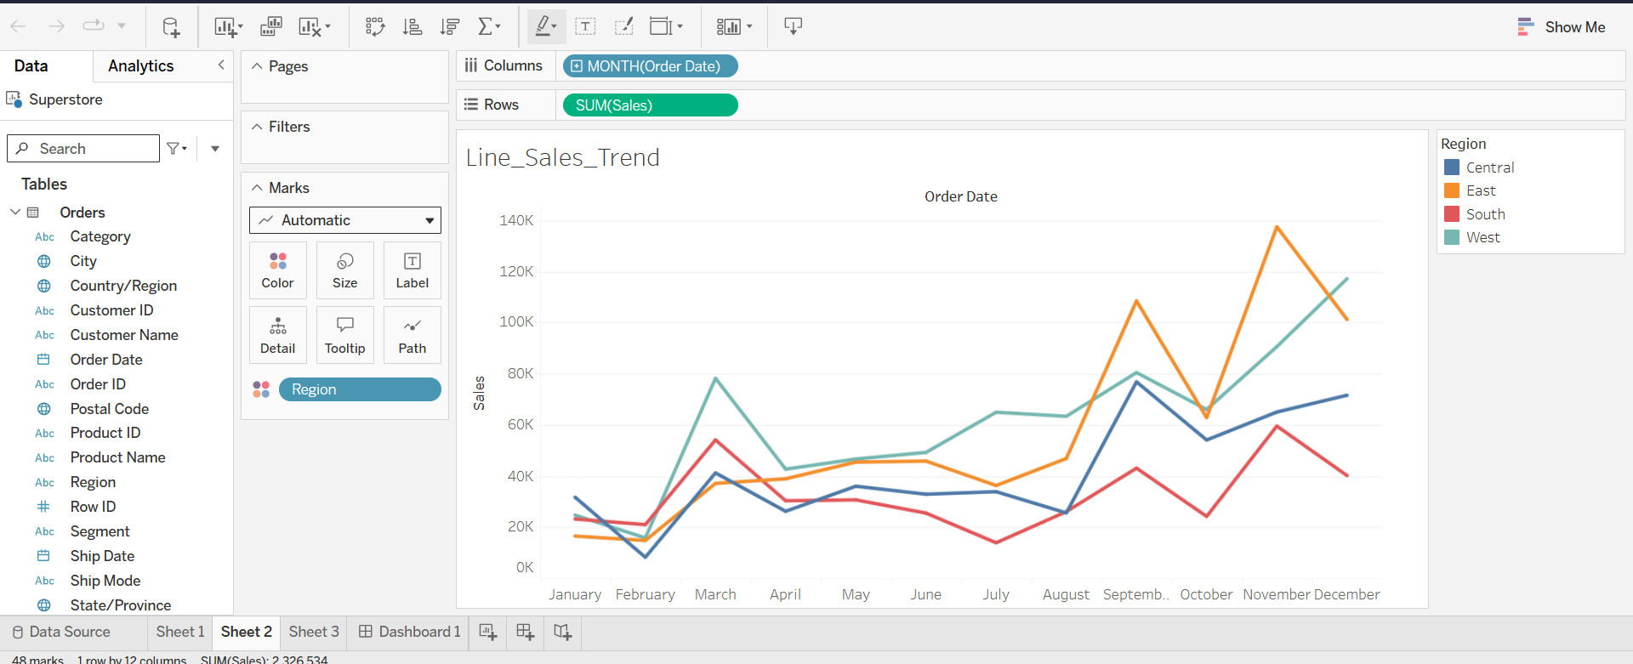

Figure 3: Scatter Plot – Profit vs Sales by Sub-Category
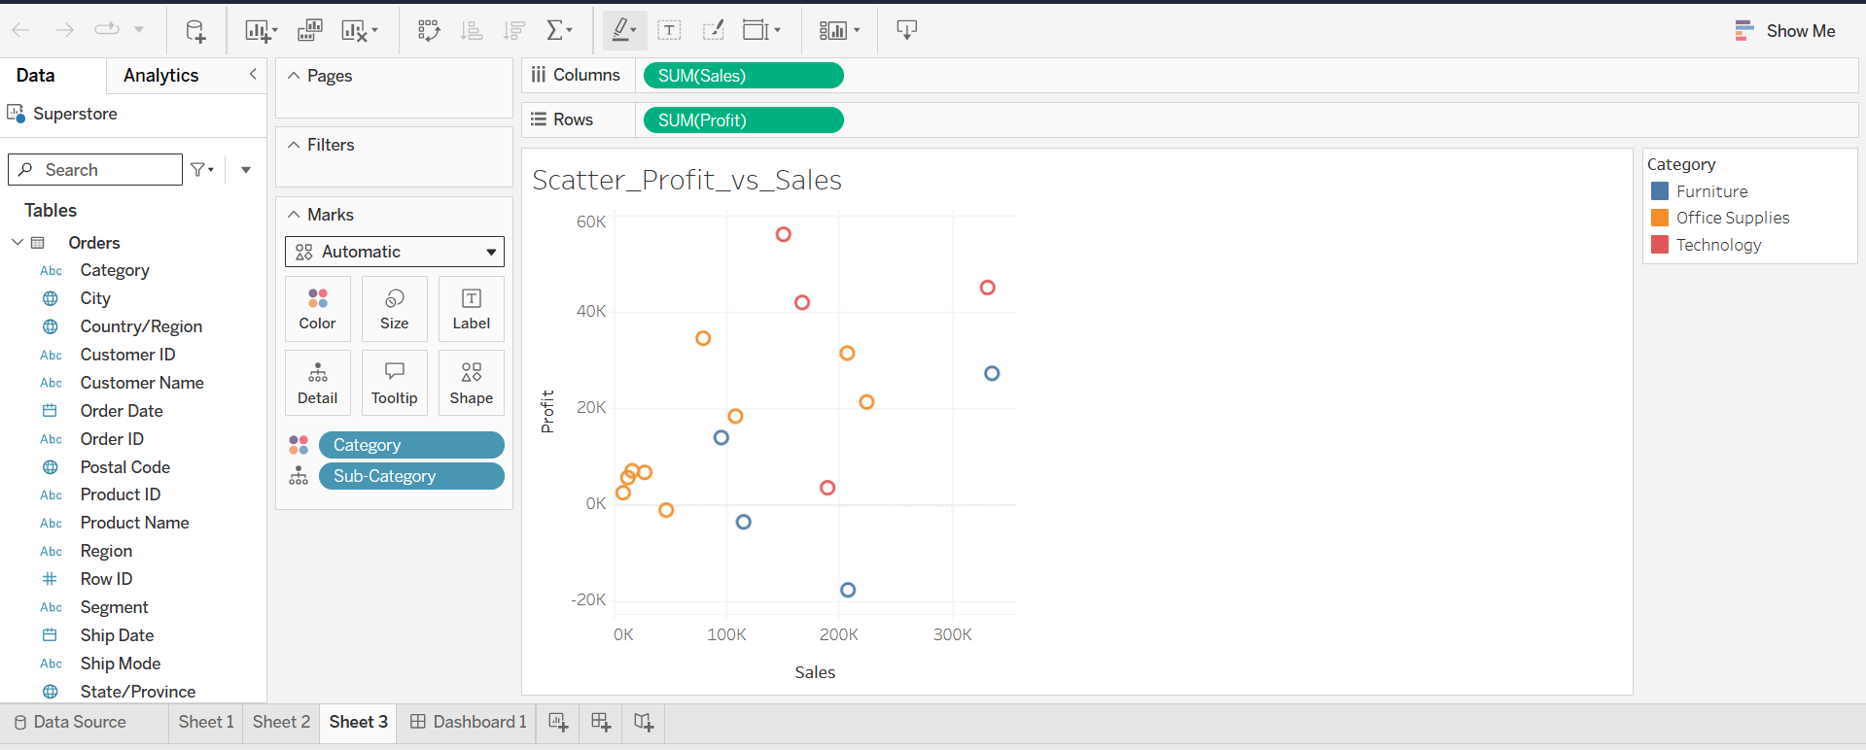
Figure 4: Interactive Dashboard – Sales and Profit Dashboard
